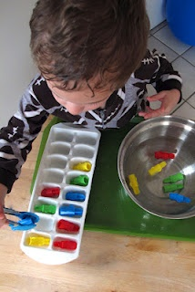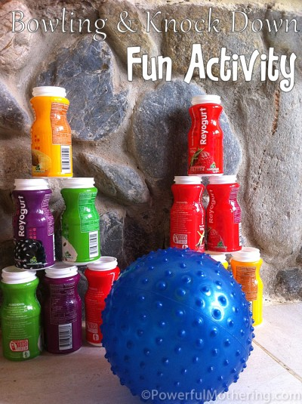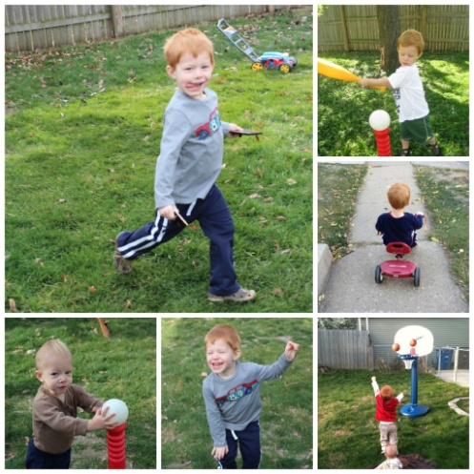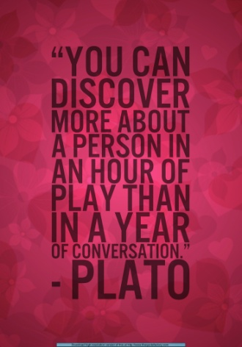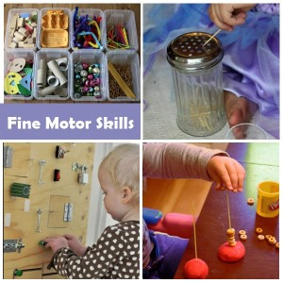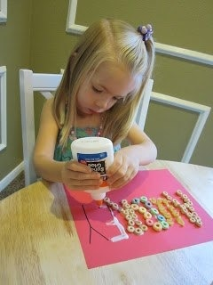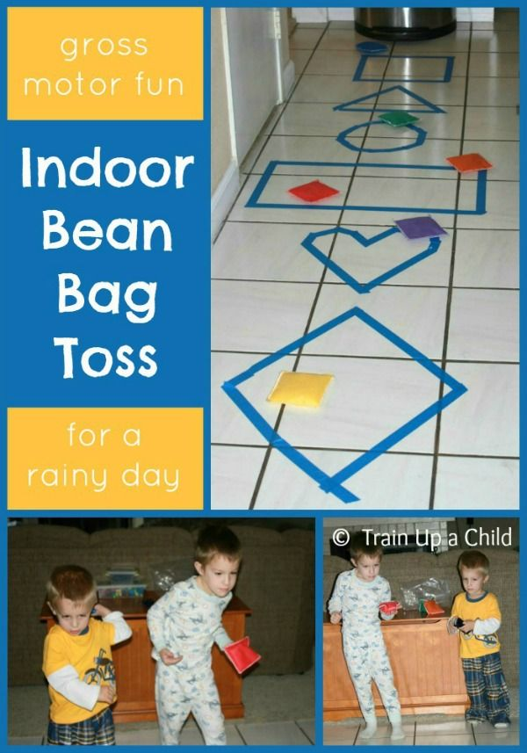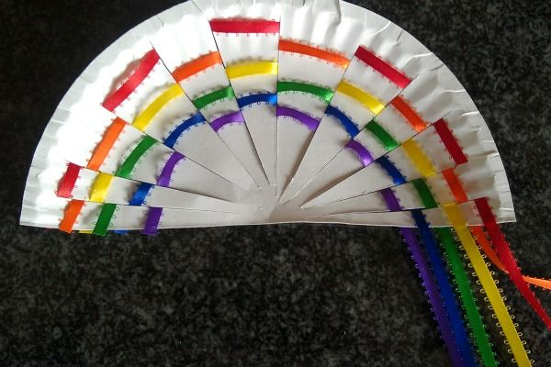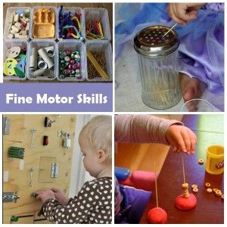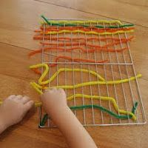

**Fine Motor Skills in the kitchen**

**Learning Support Corner-Primary**

**Fine and Gross Motor Skills**

**Gross motor skills** refer to the movement of the large muscles in arms, legs, feet or the entire body. They can be activated for example by running, jumping, climbing or balancing.

**Fine Motor Skills** refer to the smaller muscles for example in the hands and fingers, often in coordination with the eyes. They can be practised by pinching, grasping, threading, lacing, or other activities that involve the fingers. Fine motor skills are the foundation for handwriting, cutting and typing on a computer.

**Fine Motor Fun With**

**Bongos/ Cheerios**

**Activities to practice Gross Motor Skills**