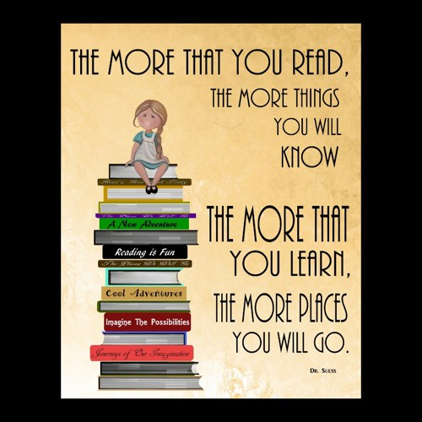

**Learning Support Corner-Primary**

**Reading** is one of the most important literacy skills in school.

**Understanding** what you are reading is even more important.

**We read to learn.**

Discuss books that you have read with your child. It will improve your child's literacy skills and thinking skills.

There is a variety of ways to make reading comprehension fun.

Try the reading dice...

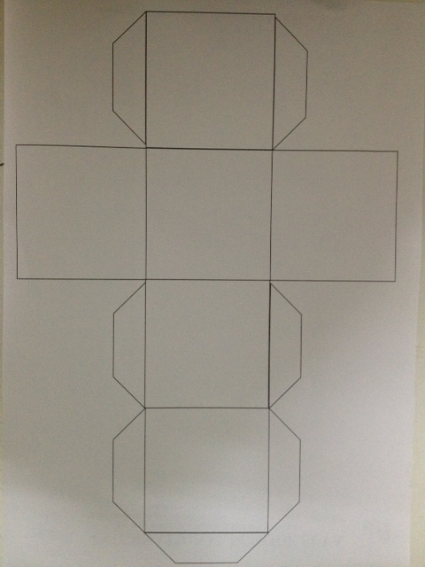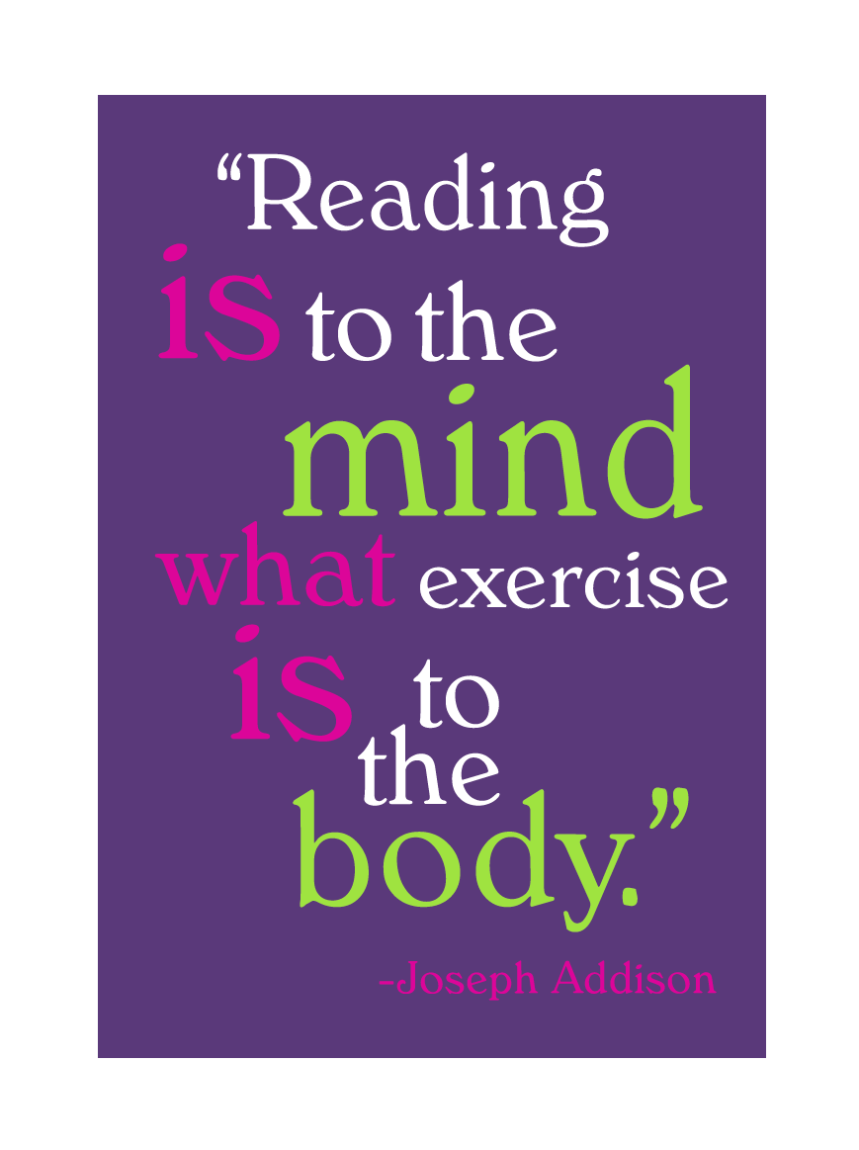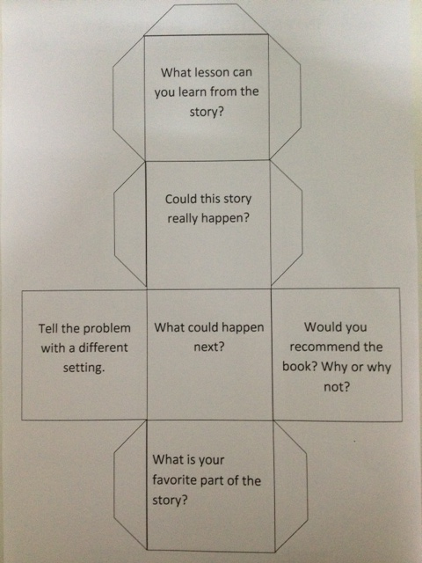

**Reading Comprehension strategy**:

**"Reading dice"**

Roll the dice and answer the questions after reading a book.

Use this dice or make your own.

Cut out and laminate to use as a bookmark.