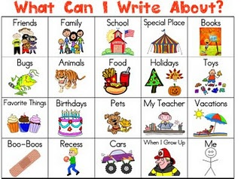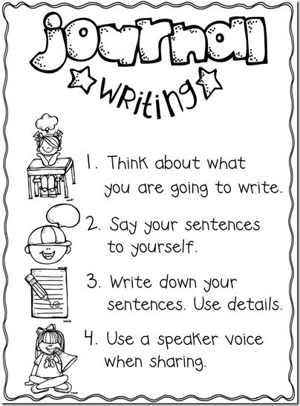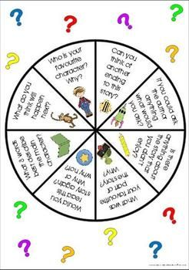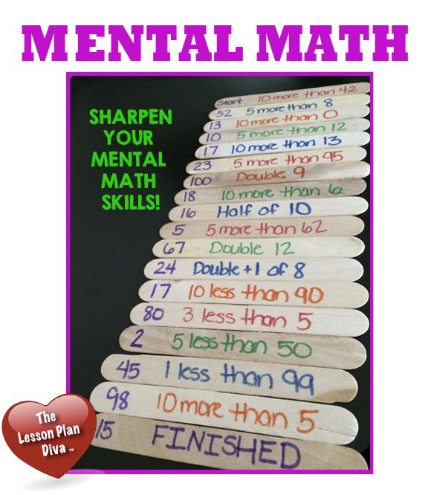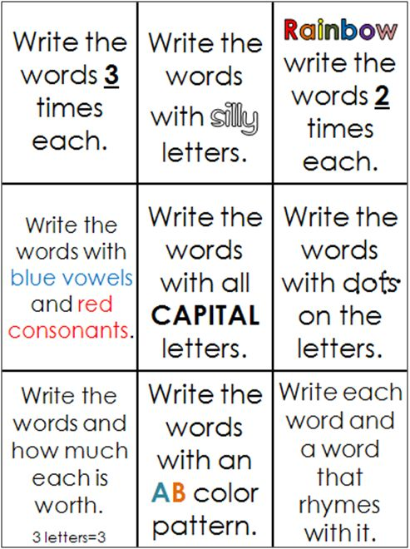

**Writing**

**Reading**

**Math**

**Learning Support Corner-Primary**

**Learning is fun and not only meant for school. Here are some great ideas to keep the learning going during the break.**

**Spelling**