**Learning Support Corner-Primary**

**Busy at home and no time to read with your child?**

**That can happen!**

**Here is a helpful tool for your child to choose a book that is on the right level and can be read alone.**

A Bubble-Along-Book is easy but interesting.

You should be able to read it all by yourself.

Do the 5 Finger Test if you are not sure if the book is right for you.



**FIVE**

**FINGER TEST**

**1.** Open the book to any page and begin reading.

**2.** Every time you come to a word you cannot read, put one finger down.

**3.** If you put down five fingers on this page, stop.

**4.** The book is probably too hard for you right now.

**5.** Choose another book, or ask someone to read this book to you.

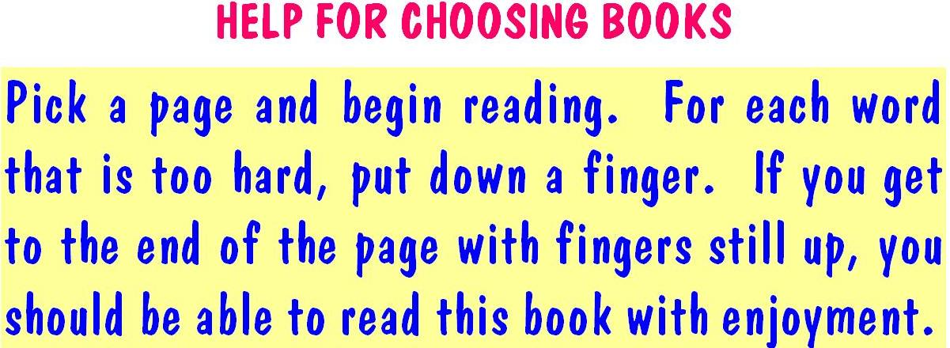



**Independent Reader Ahead**

