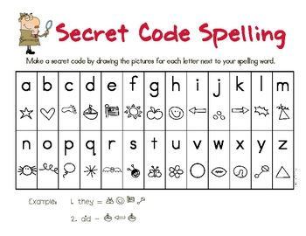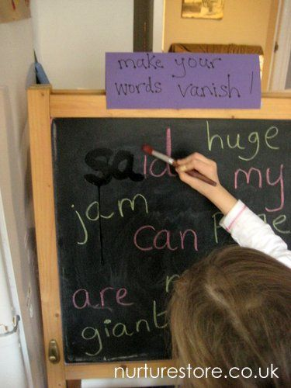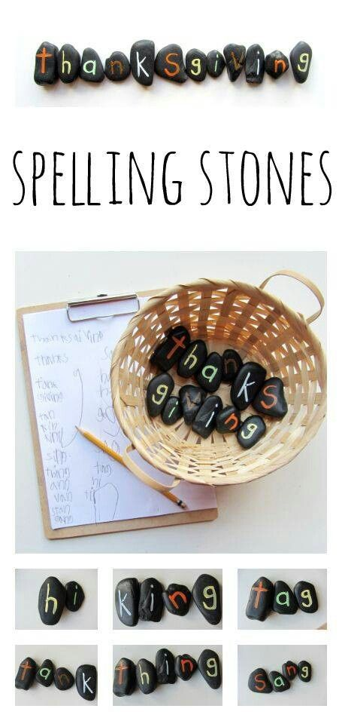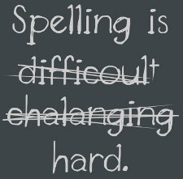

**Write a secret message in code**

**Make your words vanish**

**Who can write the most words?**

**Learning Support Corner-Primary**

**Spelling** is a very important literacy skill in school.

Spellinghelps your child with reading and writing.

There is a variety of ways to make spelling fun...