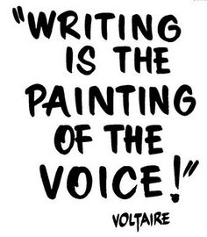

**Learning Support Corner-Primary**

**Writing**

Writing is one of the ways in which we can express our ideas and creativity. Writing is also a tool to organize our life (lists, schedules, etc.). Handwriting builds a solid foundation to be able to use writing as a tool in the future. Here are some ideas for fun handwriting activities you can try at home.

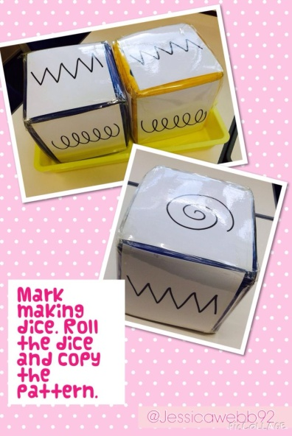

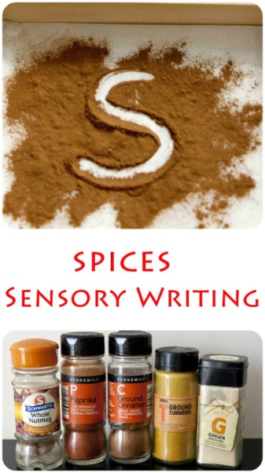

Can be used with any word.

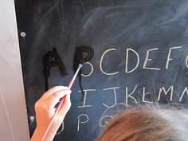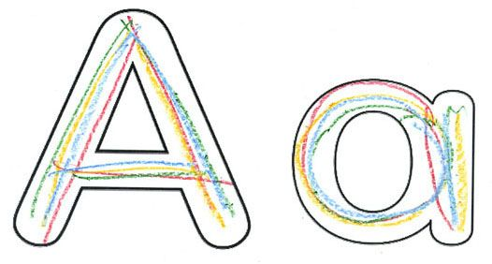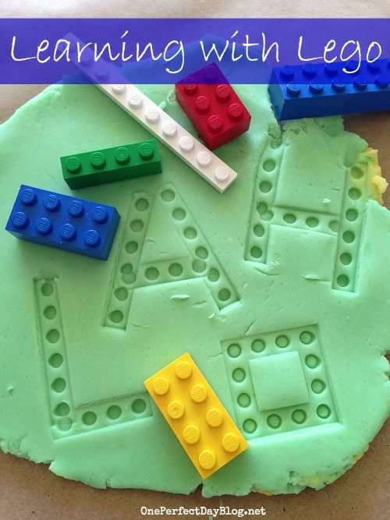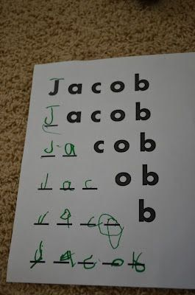

Resource: Pinterest

Works great outside as well

Rainbow writing

Any word or letter is as many colors as possible.

Also works fantastic with sand, shaving foam or hair gel. Eatable versions are with whipped cream, chocolate pudding or dough.